**Fr. Conceicao Rodrigues College of Engineering** Father Agnel Ashram, Bandstand, Bandra –west, Mumbai-50 

**Department of Computer Engineering**

**SOCIAL MEDIA ANALYTICS LAB**

**Experiment 1**

**Aim:** Study various -

i) Social Media platforms ( Facebook, twitter, YouTubeetc)

ii) Social Media analytics tools ( Facebook insights, google analytics , netlytic etc) iii) Social Media Analytics techniques and engagement metrics (page level, post level, member level)

iv) Applications of Social media analytics for business.

e.g. Google Analytics

https://marketingplatform.google.com/about/analytics/ and https://netlytic.org/ **Objective:** To study various Social Media Platforms and its analysis tools.

**Lab outcomes:**

*At the end of this lab session, students will be able to…*

1. Identify different Social Media Networks.

2. Acquire hands on skills needed to work with social media data.

**Theory:**

➢ **Social Media Platforms:**

● **Facebook:** A social networking website that allows users to connect with friends, family and other people who share similar interests.

● **Twitter:** A microblogging platforms that allows users to send and read short messages called “tweets”

● **Instagram:** A photo and video sharing app that allows users to share pictures and videos with their followers.

● **TikTok:** A short form, video sharing app that allows users to create and share 15-second videos. ● **linkedIn:** A professional networking platform that allows users to connect with other professionals in their industry.

● **Pinterest:** A visual discovery platform that allows users to discover and save creative ideas for various projects and interests.

**Fr. Conceicao Rodrigues College of Engineering** Father Agnel Ashram, Bandstand, Bandra –west, Mumbai-50 

**Department of Computer Engineering**

**SOCIAL MEDIA ANALYTICS LAB**

● **Snapchat:** A multimedia messaging app that allows users to send and receive photos and videos that disappear after they’re viewed

● **YouTube:** A video sharing platform that allows users to upload,share , and view videos ● **Reddit:** A social news and discussion platform that allows users to submit and vote on content ● **WhatsApp:** A messaging app that allows users to send and receive text, photos, videos in real time

● **Quota :** Online question answering portal

➢ **Social Media Analytics Tools:**

● **Google Analytics:** Google Analytics is a Cloud-Based Web Analytics service that delivers different tools to optimize Digital Marketing. Google Analytics gives real-time statistical-based analytics solutions about your user’s interaction with your Social Media website or app ● **YouTube Analytics:** Allowing them to track and monitor crucial metrics & statistics for better optimization and performance. With YouTube Analytics, you’ll quickly be able to draw crucial viewer-driven insights about your audience such as audience retention, real-time activities, etc. ● **Hotspot:** HubSpot is one of the most popular Social Media Analytics Tools used by companies to manage and attract customers, generate leads, and provide services. HubSpot offers several tools to create and host web pages, blogs, emails, and manage interaction with customers. **Pinterest Analytics:** Pinterest Analytics categorizes the Analytics Section into 3 parts: Profile, Audience, and Website Analytics. Profile Analytics shows you the list of pins people liked most from your profile in the last 30 days, the number of times your pins were visible in the feed, and other insights. Audience Analytics shows you the demographics of your audience, like their gender, where they live, their interests, etc. You can compare your audience against the overall Pinterest audience to see where they fall. These crucial insights can help you decide what to pin next.

● **LinkedIn Analytics :** LinkedIn Analytics will make it easy for you to analyze and measure performance dynamics. LinkedIn offers distinct, and basic analytics about your followers, visitors,

**Fr. Conceicao Rodrigues College of Engineering** Father Agnel Ashram, Bandstand, Bandra –west, Mumbai-50 

**Department of Computer Engineering**

**SOCIAL MEDIA ANALYTICS LAB**

and connections. It’ll help you understand more about who exactly is engaging with your Business Campaigns and Posts.

➢ **Social Media Analytics techniques and engagement metrics**

Multiple network metrics combine specific results from the social networks, Pages, and accounts you have connected to Hootsuite. This helps you understand your average performance for your most important metrics.

**Page Metrics**

**Fr. Conceicao Rodrigues College of Engineering** Father Agnel Ashram, Bandstand, Bandra –west, Mumbai-50 

**Department of Computer Engineering**

**SOCIAL MEDIA ANALYTICS LAB**

**Post Metrics**

➢ **Applications of Social media analytics for business**

**Sentiment Analysis**

○ Social Media Analytics can be used to analyze the Sentiment of customers

towards business or product.

○ It provides an insight into how people feel about product /service/business. **Audience Segmentation**

**Fr. Conceicao Rodrigues College of Engineering** Father Agnel Ashram, Bandstand, Bandra –west, Mumbai-50 

**Department of Computer Engineering**

**SOCIAL MEDIA ANALYTICS LAB**

○ Social media analytics can help businesses to **segment their audience** based on

factors such as **demographics, interests, and behavior**.

○ It allows for **more targeted marketing efforts**.

**Brand Monitoring**

○ Social media analytics can be used to **track mentions** of a **business or brand** on

social media, providing insight into h**ow people perceive the company. Campaign Analysis**

○ Social media analytics can be used to measure the **success of marketing**

**campaigns** and to **identify areas for improvement.**

**Content Analysis**

○ Social media analytics can be used to **track the performance of different types**

**of content**, helping businesses to understand **what types of content are most effective.**

**Market Research**

○ Social media analytics can provide businesses with **valuable insights** into **market**

**trends and customer needs and preferences.**

**Social Listening**

○ By **monitoring social media for mentions** of a business or industry, businesses

can stay up-to-date on industry developments and **identify opportunities for growth.**

**Fr. Conceicao Rodrigues College of Engineering** Father Agnel Ashram, Bandstand, Bandra –west, Mumbai-50 

**Department of Computer Engineering**

**SOCIAL MEDIA ANALYTICS LAB**

**Crisis Management**

○ Social media analytics can help businesses to **quickly identify and respond to**

**any crises** that may arise, such as **negative press or customer complaints. Competitor Analysis**

○ Social media analytics can be used to **monitor the activities and strategies** of

**competitors,** providing businesses with valuable insight into their own performance in comparison.

**Customer Service**

○ Social media analytics can help businesses **track and respond to customer**

**inquiries, complaints, and feedback** in **real-time**. This can improve customer satisfaction and loyalty.

**Students’ task:**

1. **List company and its official social media accounts ( Select company of your choice)**

### Microsoft:

* Twitter: @microsoft
* Facebook: Microsoft
* Instagram: @microsoft
* LinkedIn: Microsoft Corporation
* YouTube: Microsoft

### Apple:

* Twitter: @apple
* Facebook: Apple
* Instagram: @apple
* LinkedIn: Apple Inc.
* YouTube: Apple

1. **Find the count for social each social media account( from task1) measuring success.( Followers)**

**### Apple :**

* Twitter: @apple (97.6 Lkh)
* Facebook: Apple (1.4 Cr)
* Instagram: @apple (3.2 Cr)
* LinkedIn: Apple Inc. (1.7 Cr)
* YouTube: Apple (1.9 Cr)

**### Microsoft :**

* Twitter: @microsoft (57.8 M)
* Facebook: Microsoft (22.7 M)
* Instagram: @microsoft (35.3 M)
* LinkedIn: Microsoft (16.8 M)
* YouTube: Microsoft (12.1 M)

1. **How often these companies visit the social media accounts?**

**Twitter:** Apple & Microsoft post multiple times per day (morning and afternoon).

(Respond to tweets within a few hours of being posted)

**Facebook:** Apple & Microsoft post frequently, multiple times per day.

(Responses to comments or likes within a few hours)

**Instagram:** Apple & Microsoft posts are generally made once or twice per day.

(Instagram does not have a direct messaging feature like Twitter or Facebook, so there are no replies to speak of)

**LinkedIn:** Apple and Microsoft post updates and share content a few times per week.

(They engage with comments and messages moderately throughout the week)

**YouTube:** Apple and Microsoft upload new videos periodically, but the exact frequency varies.

(They respond to comments on their videos within a few days)

1. **What kind of interaction the company is doing? Broadcast, request for input, direct interaction or a combination? Provie example for each.**

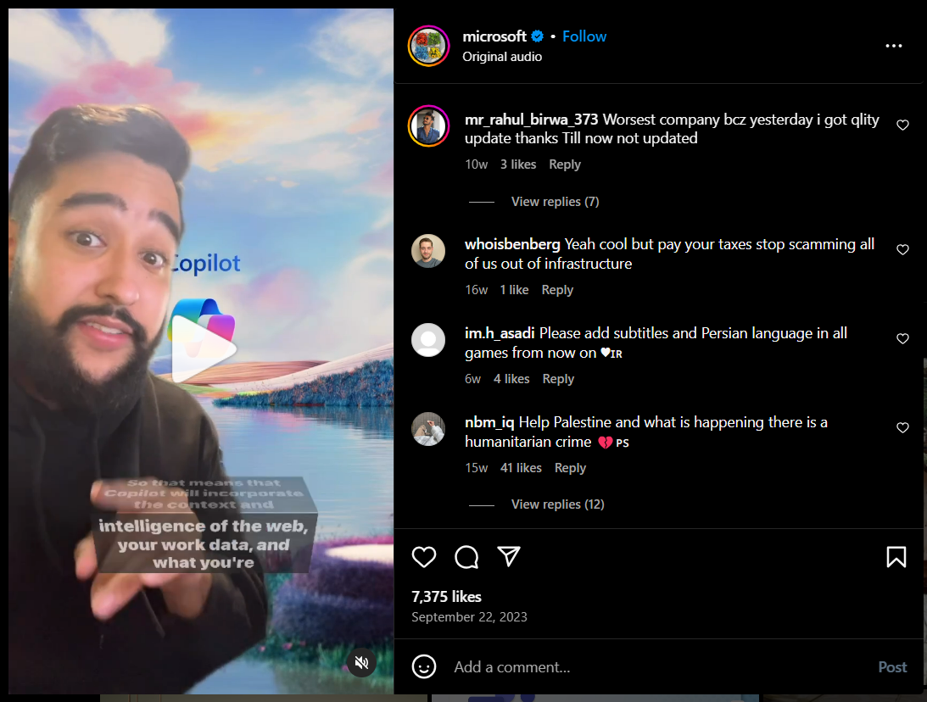

5. **Explore** Tool 1: https://www.noxinfluencer.com/

Platform: Youtube

Public Account**: Your Choice (Example** Lex Fridman (podcaster))

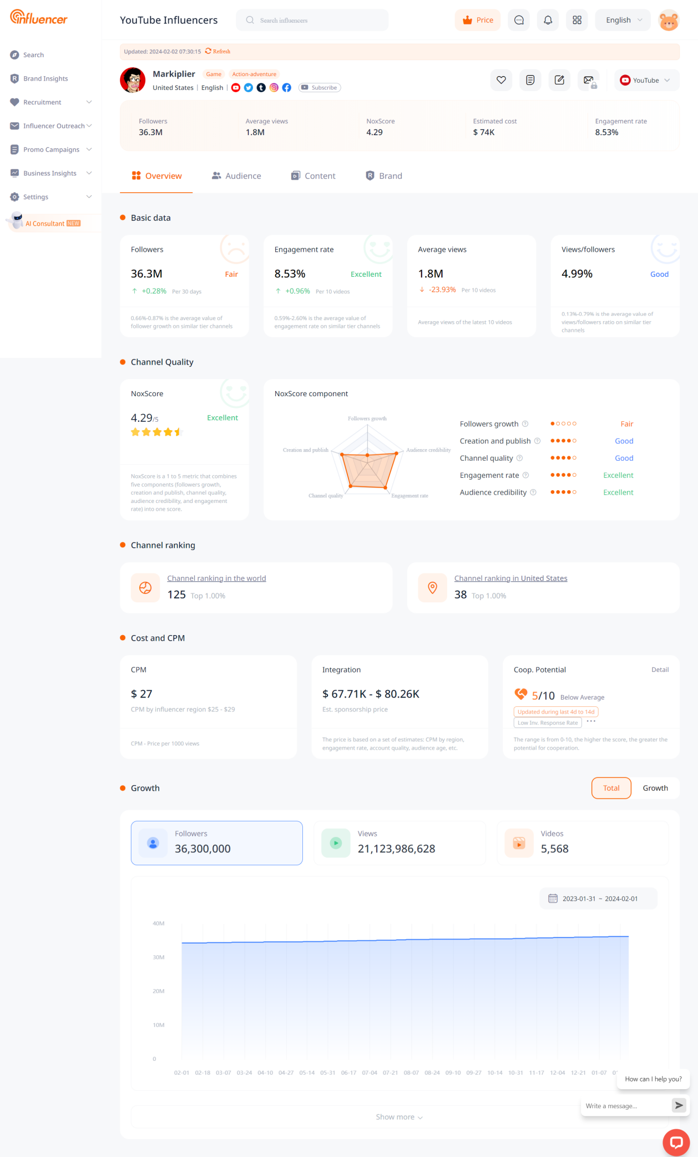

Platform: instagram

Public Account: **Your Choice (Example** Joe Rogan (Podcaster))

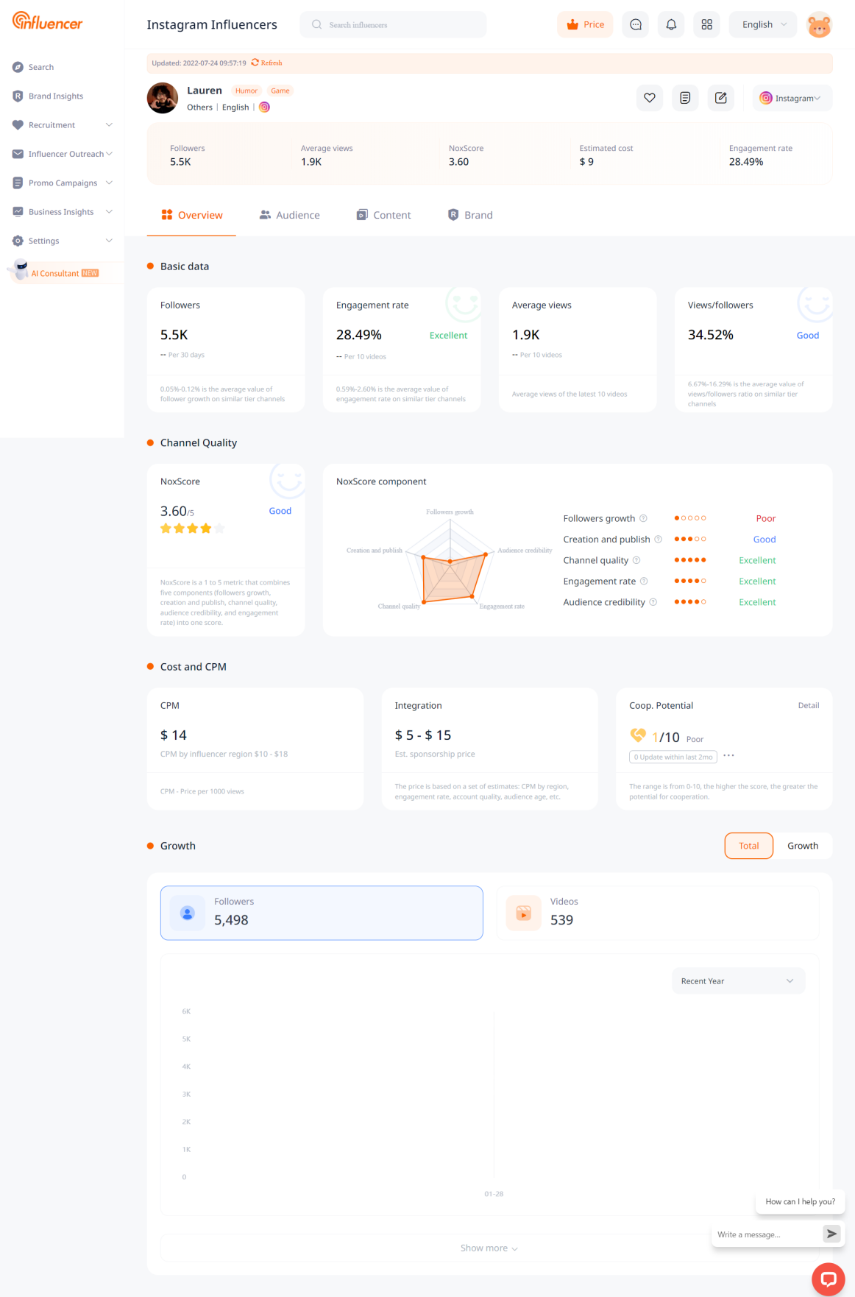

**Fr. Conceicao Rodrigues College of Engineering**

Father Agnel Ashram, Bandstand, Bandra –west, Mumbai-50 

**Department of Computer Engineering**

**SOCIAL MEDIA ANALYTICS LAB**

6. **Explore** Tool2 : https://instrack.app/

Public account : **Your Choice (Example** (Lionel Messi))

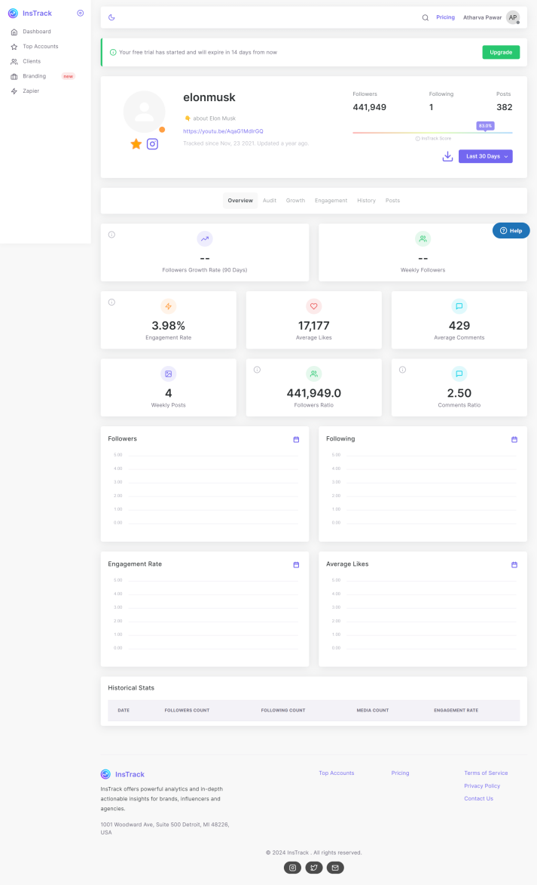

7. **Explore** Tool 3: socialblade

Public account : (Example-Gigguk)

Social platform : Twitch

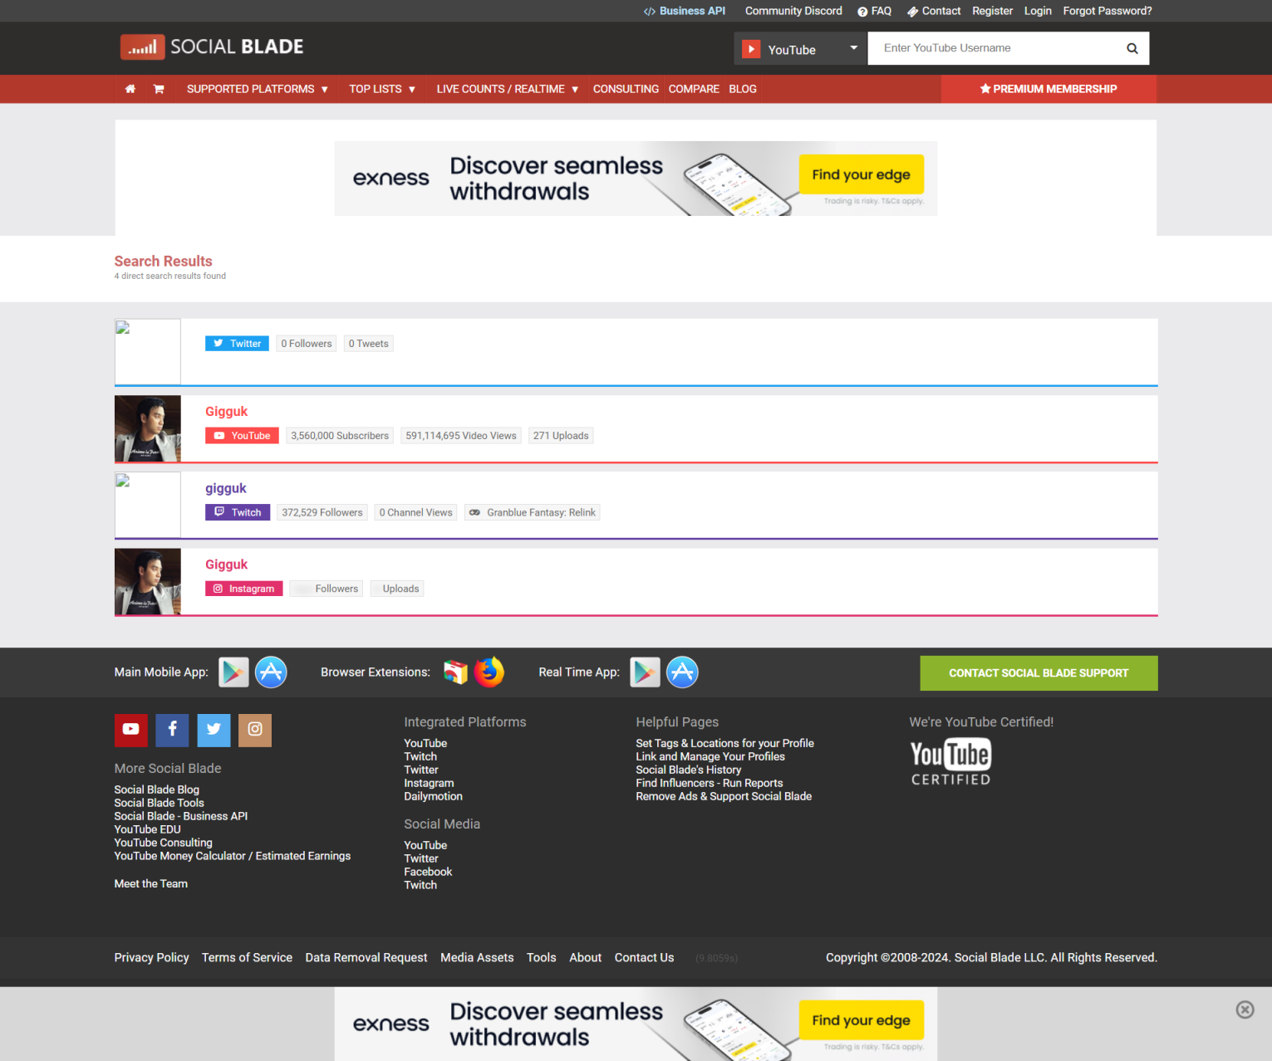

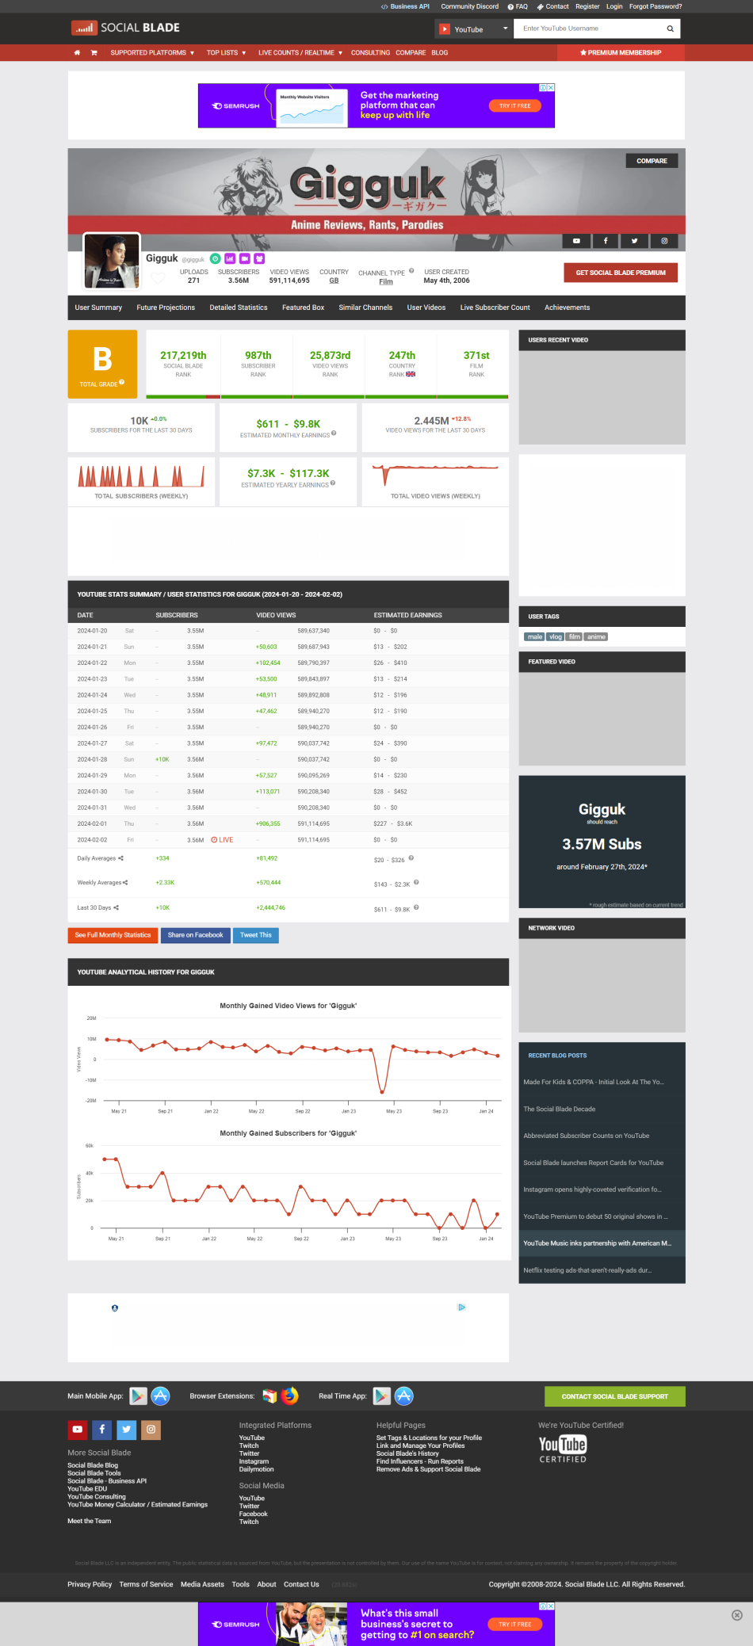

8. **Explore** https://netlytic.org/ for the following inputs

1. On Twitter , text analysis of your choice dataset

(discontinued)

2. On Twitter , network analysis of your choice dataset

(discontinued)

3. On Youtube , text analysis of your choice dataset

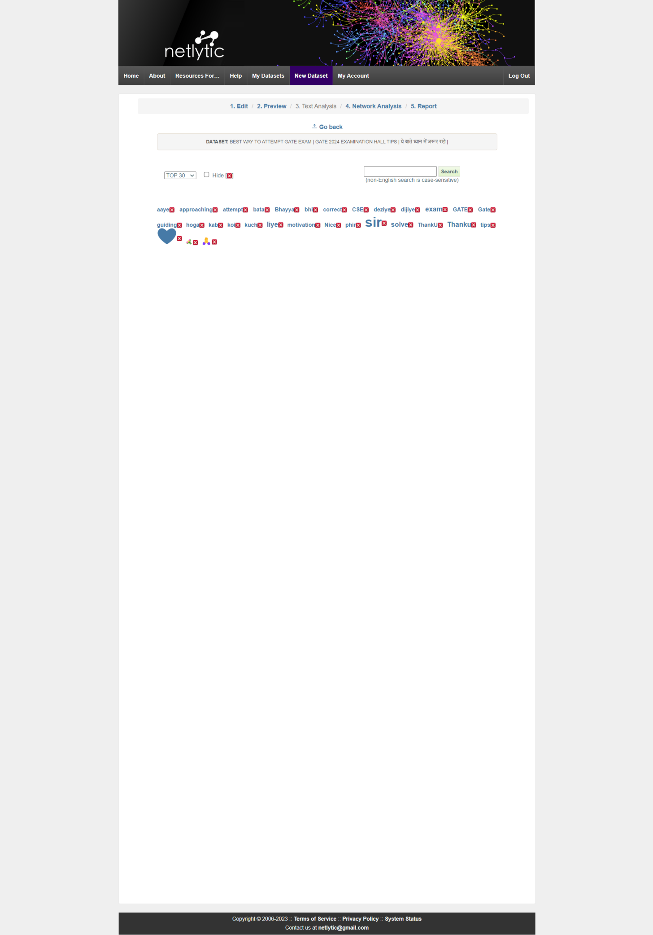

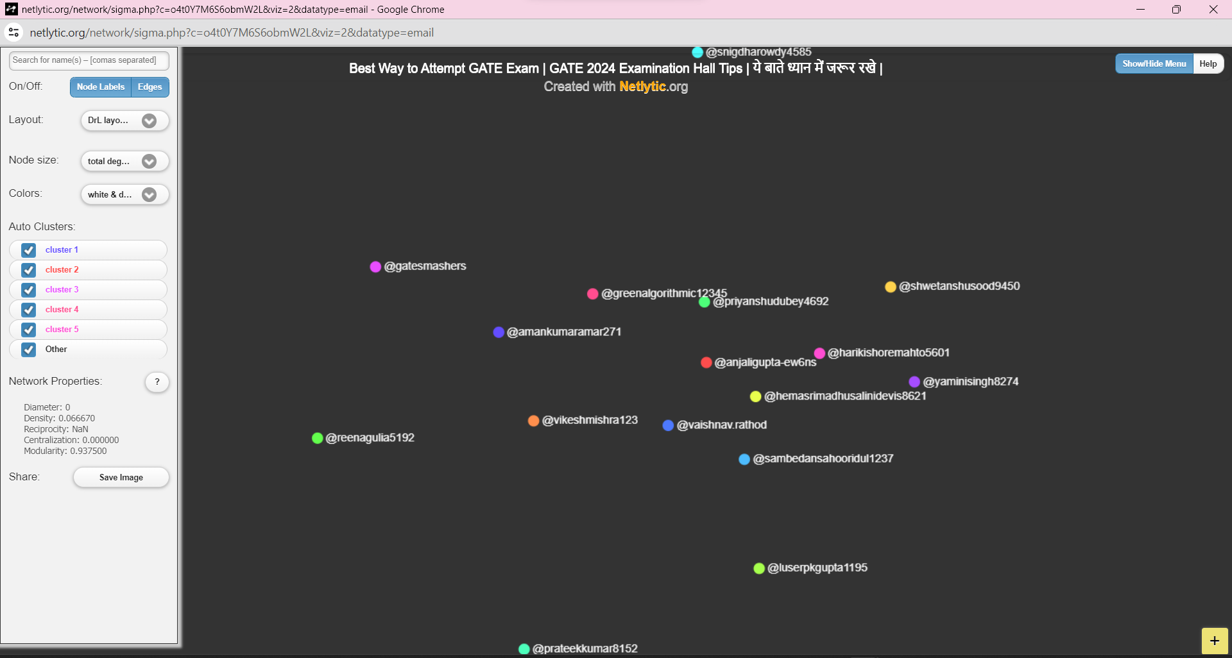

4. On Youtube, text analysis of your choice dataset

